**4Cast**

**April 2013 v1**

LEGAL NOTICE

*ASU30*

*ASU30 and ATUU30 are acronyms for Adult Smoker Under 30 and Adult Tobacco User Under 30. The term ‘adult’ is defined by local law, but shall in no circumstance refer to any person under the age of 18. Likewise, consistent with BAT’s International Marketing Standards, terms such as ‘consumer’, ‘target consumer’, ‘smoker’, or ‘target audience’ refer only to smokers whom are adults.*

LOCAL LEGISLATION / REGULATIONS

*The material contained in this document may present executions and themes that are not legally permissible or acceptable in some markets. Likewise, because tobacco regulation and the company’s own views on socially responsible marketing change over time, previously approved activities may no longer be permissible. Therefore, you must obtain local legal and CORA approval before proceeding with any activity in your market.*

*COPYRIGHT AND CONFIDENTIALITY*

*© British-American Tobacco (Holdings) Limited 2013. All rights reserved. No part of this document may be reproduced in any form or any means without the prior written consent of British-American Tobacco (Holdings) Limited (˝BAT˝).*

*This document is proprietary to BAT and is provided to employees of the BAT Group and certain trusted contractors working for a member of the BAT Group. It is disclosed solely for use by employees in the course of their employment or by contractors for the purpose of facilitating the provision of services by that contractor to the employing BAT company and for no other purposes. Unauthorised possession or use of this material or disclosure of the proprietary information without the prior written consent of BAT may result in legal action.*

*THIRD PARTY TRADEMARKS*

*“Trademarks, logo designs and/or brand names featured in this material and not owned by British American Tobacco PLC (or one of its group companies) are owned by the relevant proprietor of the particular trademark and/or brand name in question, and are referred to in this document for informational and/or illustrative purposes only.”*

Contents

1. Overview – 4Cast Study: 3

2. How to set up a 4Cast Study? 5

2.1 Sample Size and type: 5

2.2 Stimulus materials and requirements: 8

2.3 Interview location and requirements: 10

2.4 Validation Process: 10

3. The Interview and Questionnaire flow 12

3.1 Interview Flow: 12

3.2 Questionnaire flow and information areas: 14

4. Key Metrics and Analytics 17

4.1 Action Standard Setting: 17

4.2 Key Deliverables: 17

4.2.1 Volume share potential: 18

4.2.2 Diagnostics of mix element performance: 20

4.2.3 Comparison with Normative data: 20

4.2.4 Brand Equity Uplift: 21

4.2.5 Occasions and Moments Analysis (Optional): 23

4.2.6 Price Elasticity Module (Optional): 23

5. Agency for 4Cast 23

# Overview – 4Cast Study:

4Cast is part of the new BAT 4Suite Innovation Testing toolkit. The methodology has been designed to validate the market share potential of a final offer *(with all marketing mix elements complete and ready for launch)* prior to taking final launch and resource allocation decision.

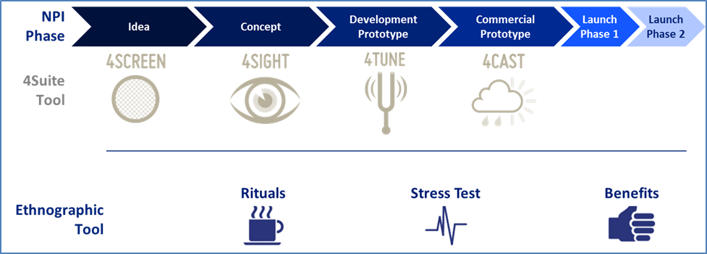

4Cast will provide a comprehensive evaluation of the final offer and a market share potential of the offer along with marketing mix diagnostics. 4Cast can be used with both a new brand /offer or with a re-launch and marketing mix change of an existing offer. This tool replaces the earlier *Simulated Test Market (STM).*

The key business question that 4Cast helps to answer:

* ***Is the potential market share of this offer after 12 months of the launch large enough to justify the launch and investment of resources?***

4Cast estimates the potential of the offer by providing a robust volumetric share potential projection as well as mix elements diagnostics to understand what is driving or hindering the potential.

In addition to providing a volumetric share projection – 4Cast includes benchmarking to the BAT tobacco database as well as the Kantar TNS ex-category innovations database. These benchmarks will help us to understand how the tested offer performs on the main indicators against other tobacco and ex-category benchmarks.

4Cast is in essence a simulation of the launch. The respondent will evaluate the final and full marketing mix. 4Cast design includes a 1-stick smoking experience during the first visit, a 2 days product placement at home followed by a second and final visit and interview. This comprehensive design will give us a good understanding on the respondent’s expectations, judgment after a 1 stick trial and the intention to purchase after testing the product for two days. All of these elements help us to simulate and review the potential success of the launch and whether the offer is consistently interesting and appealing throughout the test.

4Cast is mandatory for Cap3 and Cap2 projects for agreed lead markets (T15 and GFM). 4Cast is optional for Cap1 projects.

Also the following basic rules apply with 4Cast:

* Mandatory for T15 for any changes to the marketing mix for Global Drive Brands and Regional Brands or any high volume and high risk local brands.
* Mandatory for T15 and GFM when doing a brand migration
* Mandatory for T15 and GFM if we are making a change to the product on Core range. *(For example changing from regular product to a capsule range)*

The objective of 4Cast is risk mitigation – therefore it is mandatory in high risk and high investment situations as stated above. Any deviation from these standards requires a waiver.

# How to set up a 4Cast Study?

4Cast is a quantitative test that is done with a *monadic* panel setup where each respondent will test one offer. The test can be done at a central location or at the respondent’s home or chosen location. It is mandatory that the first visit is done face to face however if logistically feasible and efficient the second visit may be done over phone or on-line.

At minimum 4Cast has one panel to test the new offer. The following principles need to be followed:

* *When testing a new brand and one offer – minimum requirement is one SOB panel.*
* *If several offers are tested at the same time – this requires setting up matched panels that can test the offers simultaneously.*
* *When testing a line extension for an existing brand in the market – it is recommended to include in addition to the SOB panel the OWN*

*franchise panel to measure cannibalisation and the net share gain.*

* *If the offer tested is a re-launch or a replacement of a current offer in the market – a control panel testing the current offer is mandatory.*

## Sample Size and type:

The main objective of 4Cast is to calculate the full potential of the offer within a market – the minimum sample size is 300 smokers. Markets with high category diversity and regional differences would require an even higher absolute sample size. In order to calculate a total market share projection the sample needs to cover minimum 80% of the market.

Typically an *all market target group* would include representative parameters like:

* *Demographics* such as *Age* (adult smokers up to 64 years), *Gender* or any other market relevant parameter such as *Ethnicity*.
* *Tobacco Segments* such as: *Price Segments, Flavour, Format* and any other market relevant parameters.
* It is not required to do a geographically nationally representative sample (such as in a GCS or segmentation) however a *good geographical spread and regional representation* should be guaranteed. Especially if there are significant regional skews in terms of brand usage all such regions must be represented in proportion to their contribution to overall market volumes.
* Any *geographical* *centre* where fieldwork is done must yield at minimum 30 interviews.
* Any *key tobacco segment* needs to have at least 25 interviews as minimum within the sample.
* Due to the minimum sample requirement of 30 and 25 respectively some small regions or segments may need to have a higher than fair sample size and this in turn will drive the overall sample size up. Whilst we can over and under represent segments and brands in the sample to some degree we need to ensure that *the ratio between proportion in market and proportion in sample* does not exceed 1.3.
* Whilst the starting point for the 4Cast is always to include the entire market – we have to consider *legal limitations* that we have on testing tobacco products. *The BAT Group policy is not to ask consumers to test products from a higher Tar category than what they are currently smoking as their Regular or Occasional brand.* For example if the new concept that we are testing is a FF product – it is only possible for us to do the testing among FF smokers. This means that we will have to exclude the lower Tar smokers from the test and assume that their yield to the volume share potential is zero. The research proposal has to clarify any groups that are excluded for legal reasons – their size and the assumed yield. Total market projection will take these consumers into consideration with a zero yield. Please note that to ensure proper quality of the share projection we can only leave out groups that are not allowed from an ethical or legal point of view.

There may be some special cases where on purpose the testing is done only amongst a certain limited target group – rather than testing for the all market potential. For instance we might want to test only amongst Female or only amongst ASU30.

In such case the first thing to do is to align all the BAT stakeholders to be sure that there is clear consensus on the objective. Doing a limited target group study has some negatives that need to be taken into consideration:

* With a limited target group study we will *not be able to use properly the innovation norms or the ex-category norms.* The norms that we have assume an all market setup.
* We will also not be able to add these studies to the normative database.
* There may well be surprising potential for the offer outside of the target group which the study will now not count in and the potential seems smaller than it would have been in reality.

The standard 4Cast design is always based on a total market projection in order to provide a good input to the launch decision. *Therefore any limited target group 4Cast requires the sign off from Global Oracle Manager.*

In case we are conducting a limited target group 4Cast – the coverage must be at least 80% of the specified target group to qualify for share projection within the target group.

In any limited target group study the *share projection will be strictly limited to the same target group.* Action standards need to be aligned to the study design and built for the same target group.

For both all market and limited target group 4Cast it is also possible to add boosters to cover specific segments or brands. The basic rule of covering 80% of the intended target group applies also within the booster. The minimum sample size for any sub-group / booster share projection is 150.

The all market sample does not allow automatically a share projection within the particular target group of the launch. Therefore when planning the sample size one needs to consider if it is important to have additionally a read among key target group for instance Premium Smokers. If yes then the sample needs to be boosted accordingly to allow 150 respondents within the core target group.

As *boosters increase considerably the cost and timeframe of the study* the necessity of them should be discussed with key stakeholders in advance and their role in the decision making clarified. Boosters should only be included if there is a clear business reason to do it.

## Stimulus materials and requirements:

4Cast study requires a comprehensive final offer exposure to ensure that we are indeed simulating the potential launch experience. It is very important to look at this from a launch simulation perspective when planning for the stimulus materials. It is essential that we cover accurately and thoroughly all the materials that the consumer is likely to be exposed to at the time of the launch.

The following stimulus materials are needed for 4Cast:

* **Final Product** that is planned to be launched. Products are needed for both the 1-stick experience and the 2 day home placement.
* **Final branded packaging** (products inside for home testing). The packs should have all the usual features including price stickers if those are used in the market.
* **Price** for the offer. Either printed on the pack if that is a norm in the market or displayed separately at the time of the interview.
* **Communication materials** as intended for the launch. Either electronic or printed materials. *If there is any special launch mechanisms used on wider basis such as Gift of Purchase – these sorts of materials should be also simulated during the study.* If we are testing a re-launch the materials for the current offer need to be available as well.
* **Range board:** In case a full range is intended to be launched a range board displaying all the variants will be needed. This can be either a printed board or electronic version.

*All stimulus materials must always comply with the local legislation and must be approved by the local Cora/Legal before starting the research.*

Special case – White packs 4Cast:

There may be situations where it is not possible to produce the real packaging and cigarettes inside them. This may be due to legal restrictions on testing branded products with consumers or to logistical issues with printing cylinders for the packs. In such cases it is possible to conduct the 4Cast by using pack mock-ups at the time of the interview and placing the products with the consumers in *white test packs.*

The downside of the white pack 4Cast is a more artificial testing situation for the respondent and the potential impact of this to the re-purchase intention. Due to this the outcome of the White Pack 4Cast is a Share Range projection instead of a Share Point projection. The range projection is given as +/-15%.

It is very important to review the feasibility and the availability of the stimulus before starting to plan for the test and to right away discuss any stimulus material limitations with the agency.

A White pack 4Cast will always require a sign-off from the Global Oracle Manager.

Other requirements from BAT:

In addition to the stimulus materials there are some additional things that BAT will need to deliver to the agency for a 4Cast study:

* **Distribution plan / scenarios:** Monthly plan for national Weighted Distribution (especial focus on 1st, 6th, 13th period). The recommendation is to always give 3 scenarios: *Optimistic/Stretch, Realistic, and Pessimistic.* The Distribution plan / scenarios have to be agreed and signed off by the local head of Trade / Marketing Director.
* **Awareness building plan / scenarios:** Monthly plan for national Aided Awareness (especial focus on 1st, 6th, 13th period). The recommendation is to always give 3 scenarios: *Optimistic/Stretch, Realistic, and Pessimistic.* The awareness plan should take into account the planned investment into communication and always be sense-checked against another source such as GCS or KLT and signed off by the local Marketing Director.
* **Adult Smoker population size:** The base source for the population size should be the same as used for the GCS projection. The smoker incidence should be taken from GCS for Regular and Occasional smokers. It is important that we use official sources and that you agree clearly with the agency which numbers will be used and the source. Consistency across studies is also very important.
* **Retail Audit (or in-market sales data if no RA available) data** for the past 3 years. Monthly data on SKU level for all brands in the market: Volume Share and Volume.

## Interview location and requirements:

The recommendation for 4Cast is to do the interviews at central locations. The first visit is mandatory to be done face to face however the second visit can be also arranged via telephone or on-line. The amount of locations depends on the market. Especially when doing an all market projection a good geographical spread and representation of the key regions needs to be guaranteed.

For the data collection method - CAPI is recommended and mandatory in case the design includes the *Price Elasticity* module that is conducted as a choice task. For a simple design that excludes the Price Elasticity Module PAPI is also possible.

If electronic stimulus is used it is very important that the coordinating agency reviews at an early stage what sort of computers the fieldwork agency has in use. If there is any risk of bad quality computer screens that may devaluate the quality of the electronic stimuli we need to either revert to printed materials or alternatively discuss with the coordinating agency on the feasibility of arranging computers for the fieldwork agency to use.

## Validation Process:

In order to ensure high quality share projection it is very important that each 4Cast study gets validated 12 months after the launch to see how accurate the projection was. Validation is an automatic and mandatory part of 4Cast and the process will be driven by IMRB INTERNATIONAL.

Please note that we can only run the validation for 4Cast studies where the same mix that was tested was launched in the market. If any of the mix elements was changed after the 4Cast study the validation will not be relevant.

IMRB INTERNATIONAL will automatically approach the market about 12 months after the study was done to check the timing of the launch and the actual launch mix. If the mix was the same as tested in the 4Cast – the launch timing will be noted down in the normative database. Once 12 months have passed from the launch IMRB INTERNATIONAL will again approach the market to request information on the sales and market share that has materialised. Also the market conditions such as the pricing will be reviewed to see how much and what has potentially changed in the market context since the 4Cast study was done.

The latest information is fed back into the modelling and a validation is done to see how well the share projection and the actual share gained in the market are matching. The results of the validation are used to make adjustments to the model and the calibrating factors in order to improve the share projection for future studies.

# The Interview and Questionnaire flow

4Cast is a 2-visit test with pre-recruited consumers. Typically the consumers are first recruited by using various methods and quota sampling – after which the suitable consumers are invited to the central location interview where the first day interview is taken (this involves a product experience) followed by a 2 days product usage and then the second day interview.

4Cast Visit 1 interview takes about 45 minutes to 1 hour. Visit 2 is slightly shorter lasting typically 30-40 minutes. The exact length depends on the amount of modules included and the type of stimulus materials used.

## Interview Flow:

**FIRST VISIT:**

Brand Awareness, Usage & Disposition

* + The respondent will be asked a few questions regarding the brands existing in the market. The purpose is to find out if the respondent has any pre-disposed attitude towards the test brand house.

Offer Exposure

* + The full offer is presented to the consumer in the final format as intended for the launch
  + Final pack is presented
    - *IF a White Packs 4Cast is used – high quality pack mock-up is shown to the respondents.*
  + The price for a pack needs to be clearly shown and mentioned

Offer Evaluation (Pre Trial)

* + The respondent will answer a set of questions about the offer (detailed below in the questionnaire flow)

1-Stick Smoking Experience

* + The stick should be branded and exactly the same that will be launched in the market *(and exactly the same that is placed for 2 days home trial)*
  + The respondent should be given sufficient time for smoking the product

Offer Evaluation (Post Trial)

* + After the smoking experience the respondent answers again a set of questions related to the offer.

Product Placement for 2 days

* + Actual products for 2 days consumption are given to the respondent to take home

**SECOND VISIT:**

Offer Evaluation (Post Placement)

* After the product experience of 2 days the respondent answers again a set of questions related to the offer. The purpose is to capture if there is any uplift or change in perception after the actual product trial, and also to capture the product performance.

Pricing Module (Optional)

* + A truncated *“CBC like” choice task module* will be administered to review the preference of the branded concept/offer at different price points *(price range needs to be specified by BAT)*
  + This module will provide *price elasticity* of the offer. However, please note that volumetric estimation can only be provided for the price option at which the concept was first presented at and not at any other price that was exposed in the choice exercise.

## Questionnaire flow and information areas:

1. **SCREENER**

|  |  |
| --- | --- |
| **SECTION** | **QUESTION** |
| **SCREENER** | Gender |
| Center |
| Age Screening (Exact Age) |
| Age Screening (2) |
| Trade / profession screening |
| Whether participated in market research |
| Whether participated in tobacco research |
| Smoke cigarettes daily |
| Average daily consumption |
| Regular brand |
| Time with regular brand |
| Demographic questions to be included as per market needs |
| Purchase format – pack or stick |
| Purchase frequency |
| Occasional brands |
| Proportion of Regular and other brands |
| Occasions of smoking |
| Distribution of ADC into occasions |
| Regular brand disposition |

1. **MAIN INTERVIEW VISIT 1**

|  |  |
| --- | --- |
| **SECTION** | **QUESTION** |
| **BRAND AWARENESS, USAGE & DISPOSITION** | Regular brand reconfirmation |
| Prompted awareness |
| Trial in last 3 months |
| **PRE SMOKE EVALUATION** | Purchase intention |
| Packs / sticks at trial |
| Price perception |
| Overall Liking |
| Likes of the offer |
| Dislikes of the offer |
| Uniqueness |
| Relevance |
| Believability |
| Excitement |
| Main benefit |
| Perception grid |
| Image ratings of the offer |
| Overall appeal of the offer |
| Brand equity |
| **EX-CATEGORY** | Overall Liking 6 point scale for ex-category comparison |
| **1 STICK EVALUATION** | Repeat Purchase intention |
| Purchase as regular / occasional / rarely |
| Packs / Sticks at repeat |
| Repeat purchase frequency |
| Proportion of Test proposition and other brands |
| Average weekly consumption of Test proposition |
| Price perception |
| Performance versus Expectation |
| Uniqueness |
| Relevance |
| Excitement |
| Image ratings of the offer |
| Overall appeal of the offer |

1. **MAIN INTERVIEW VISIT 2**

|  |  |
| --- | --- |
| **SECTION** | **QUESTION** |
| **POST SMOKE EVALUATION** | Placement questions – on products smoked |
| Reconfirmation of regular brand |
| Repeat Purchase intention |
| Purchase as regular / occasional / rarely |
| Packs / Sticks at repeat |
| Repeat purchase frequency |
| Proportion of Test proposition and other brands |
| Average weekly consumption of Test proposition |
| Price perception |
| Performance versus Expectation |
| Uniqueness |
| Relevance |
| Excitement |
| Perception grid |
| Image ratings of the offer |
| Overall appeal of the offer |
| Brand equity |
| Likes of the offer |
| Dislikes of the offer |
| **TALK VALUE** | Sources of information |
| Recommend ability |

1. **OPTIONAL SECTIONS**

|  |  |
| --- | --- |
| **OCCASIONS (OPTIONAL)** | Occasions of smoking Test proposition |
| Distribution of weekly consumption into occasions |
| **MOMENTS FRAMEWORK (OPTIONAL)** | Moments framework |
| **EX-CATEGORY (OPTIONAL)** | Overall Liking 6 point scale for ex-category comparison |
| **FUTURE SHAPERS (OPTIONAL)** | Future shapers questions |

|  |  |
| --- | --- |
| **OPTIONAL SECTION: PRICE ELASTICITY** | |
| **PRICE ELASTICITY** | CBC like price elasticity module |

|  |  |
| --- | --- |
| **OPTIONAL SECTION: SMOKER BEHAVIOUR** | |
| **This section will move up within the Qre flow if included** | Previous brand |
| Substitute brand |
| Forming evoke set |
| Pre-Disposition of Test proposition masked by evoke set brands |

# Key Metrics and Analytics

## Action Standard Setting:

4Cast *Action Standard* should be set around the *total market share potential projection*. 4Cast will provide as an outcome a Share Point projection 12 months after the launch – if the outcome of the study is higher than the action standard share then it is considered to be met.

If the 4Cast is testing the replacement of a current offer in the market it is mandatory to have the action standard based on the Retention among OWN franchise. Additional action standard may be set on gains from SOB. In cases where the OWN franchise is very small and the risk therefore low a waiver can be requested to do the testing only for the SOB potential. Retention is expressed as the percentage of consumers who would continue smoking the product after the change.

If the 4Cast test is done by using White packs the outcome is a Share Range projection. If the action standard falls within the range, or the range is higher than the set target – the action standard has been met.

It is very important to keep in mind that any research that is based on a sample data and number of assumptions carries an error margin with it. The size of the error margin is related to the sample size used. Therefore whilst the outcome of the 4Cast is a Share Point prediction (with one decimal point) the agency will mark in the report the estimated error margin that this result carries.

## Key Deliverables:

4Cast analysis is divided into the following areas:

1. *Volume share potential*
2. *Diagnostics of mix elements performance*
3. *Comparison with Normative data*
4. *Brand Equity Uplift*
5. *Occasions and Moments (Optional)*
6. *Price Sensitivity Module (Optional)*

### Volume share potential:

* Volume share potential is calculated using a *Trial-Repeat Model*.
* In a Trial-Repeat Model, the estimates of trial and repeat purchase probabilities are derived from the purchase intention questions.
* Calibration factors are applied to the data to reduce the element of respondent over-claim for the purchase intention. Calibration is done using variables like *Cultural Coefficient and Imagery parameters.*
* For example the respondent needs to feel that the Packaging is attractive enough to try and likewise that the product tastes good. Without such basic indications of acceptance it is very unlikely that any purchase intention will actually lead to action.

* Also it is important to know whether respondent is willing to adopt this product for Regular or Occasional usage as that will have a direct impact on the overall potential of the offer. It is expected that volume contribution through Regular usage will be significantly higher than that generated by Occasional usage.
* The derived trial probability is then modelled into a cumulative trial volume (including both regular and occasional usage), month by month, based on predicted awareness build and distribution levels.
* Volume share modelling is done separately for Regular usage and Occasional usage and these are added to get final volume share potential of the offer.

#### Talk Value Adjustment:

A new offer is likely to generate a level of interest and excitement and the consumers may be telling their adult smoker friends and family about the new product. Likewise the consumers may see other smokers using the new product and become aware of it this way.

This factor – *word of mouth and the interest generated when seen* is called *“Talk Value”.* The size and extent of *“Talk Value”* factor varies between different products – some may generate plenty of it and some nearly none.

As the communication and advertising to consumers is increasingly banned across markets “Talk Value” may be a significant driver of awareness in certain markets. The 4Cast questionnaire includes a set of questions that will calculate a *Talk Value Index* for the offer and that index will be used to adjust the final share projection. For some offers this may project incremental share.

#### Cannibalisation:

The 4Cast model will also calculate cannibalisation from the parent brand. If the tested offer is a line extension or a new range for an existing brand with a clear presence in the market we need to calculate the level of cannibalisation and the net gain for the parent brand. In order to do this we will need a minimum 150 sample of the brands OWN smokers and a separate share modelling will need to be done among them.

#### Retention

In the case of a re-launch it is important to calculate the retention of OWN franchise – the percentage of consumers who will continue to smoke the product after the change. In order to do this we will need a minimum 150 sample of the brands OWN smokers and a separate share modelling will need to be done among them.

For the re-launch cases the final share potential is calculated via the following formula: ***Retention among OWN + Draw from SOB***. 150 sample of each is required to perform the full share potential.

.

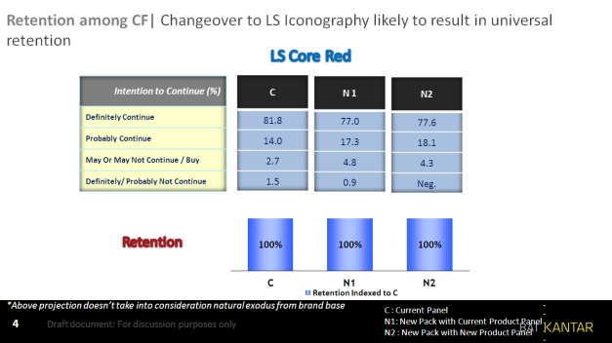 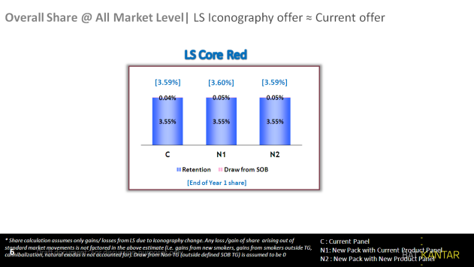

### Diagnostics of mix element performance:

The diagnostics will show us how the mix elements perform both pre-trial and post-trial and whether the product placement has any impact on the overall evaluation of the elements. The diagnostics is done separately for each mix element of the mix: *packaging, brand, stick, communication, and product.*

Additional open ended questions will help to evaluate the offer performance.

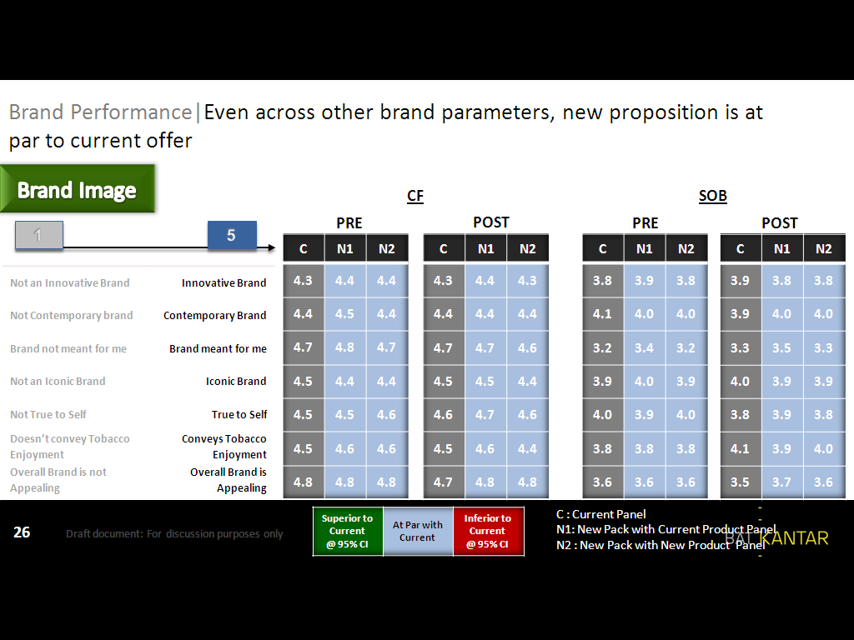

### Comparison with Normative data:

The 4Cast studies will be compared and based on a BAT normative database which is maintained and updated by IMRB INTERNATIONAL. The base is the vast range of STM studies done in the past and all future 4Cast studies will be part of the database.

As the use of a normative database is a new thing for BAT and the amount of suitable benchmarks varies a lot across markets it is very important to discuss the availability of the benchmarks with IMRB INTERNATIONAL right at the outset of the study.

What is getting benchmarked?  *Overall Appeal, Good Taste, Value For Money, Pack Attractiveness and Product Quality* can be benchmarked against the database to see in which quartile the offer is positioned in. This will give a further idea on the future potential compared to other offers.

The Ex-Category benchmarking (beyond Tobacco Category) is an optional module within 4Cast and if included is done by utilizing the TNS normative database. Depending on what type of innovation we are testing the agency will propose a suitable benchmark from the database. For instance the benchmark can be “durables” or “non-durables” depending on whether we are testing an innovation like a “maker” or ready-made cigarettes.

Important to note that only key concept measures like *Uniqueness, Excitement, Believability, Relevance and Appeal* can be benchmarked to Ex-Category norms.

### Brand Equity Uplift:

The Brand Equity Uplift score measures the effect of offer performance on parent brand equity to help identify offers likely to gain amongst competition. It is measured as percentage uplift in parent brand’s equity due to experience of the new offer. This will help us to understand if the new offer has any impact on the Brand Equity of the Parent House brand. The uplift measurement is based on an evaluation of equity dimensions of the Parent House brand before and after exposure to the product placement.

In the pre-placement assessment, the Brand Equity module is included at the beginning of the 4Cast questionnaire, before the respondent is aware of the exact topic of the interview and the new offer. The module – including an Association Grid and additional product attributes – is administered to a relevant set of **3-5 brands**. The brands will consist of the respondent’s regular brand, test brand and a couple of relevant brands from same or adjacent price category that the respondent is aware of.

The brand attributes included in the equity module are below, and are evaluated within an Association Grid format:

* *Appeals to you more than other brands*
* *Is a brand for someone like me*
* *Is a brand that is setting the trends*
* *Is a brand that meets my needs*
* *Offers something different from other brands*
* *Is a brand that I have a higher opinion of*

In addition to the Brand Equity Association Grid, the module includes a set of product and quality related attributes to be rated for capturing negative or positive dispositions and uplift towards the brand holistically.

Equity Uplift Calculation:

The Brand Uplift score within 4Cast is based on a weighted sum of the pre-post differences in the six dimensions.

The Uplift score is represented as a % improvement in equity:

***Uplift Score % = (post sum - pre sum) / pre sum***

For offers that involve a new brand not currently existing in the market, the pre-sum Brand Equity is assumed to be zero. In this case, a post-measure would still be calculated to understand the equity value generated by the new offer.

The resulting Brand Uplift score represents the degree to which the new offer is helping to improve the equity of the brand house. In order to identify if the uplift is statistically significant, Post and Pre weighted averages of the six dimensions are evaluated to assess significant difference. If the difference is significant, then the % Uplift score represents an improvement.

The Brand Equity scores and uplift scores are stored in the normative database and over time we will be able to compare against the norms built from the studies.

### Occasions and Moments Analysis (Optional):

This module is evaluated by seeing which Occasions are most appropriate for the offer and whether the offer is over or under indexing on any specific smoking occasion compared to regular brands smoked by the respondent.

### Price Elasticity Module (Optional):

Price Elasticity is measured through a *choice based conjoint exercise* which is done at the end of the interview. Discrete choice tasks are created from the test offer and existing key brands in the market and these are presented to the respondent at different price combinations. Same technique is used here as what we use in the CBC pricing study.

The outcome is the price elasticity of the test offer across the exposed price range.

Please note that this module requires separate programming and analytics therefore it is important that the PIB will already specify that a Price Elasticity Module needs to be added. The price range where elasticity is tested needs to be decided in advance by BAT. If the Price Elasticity Module is added the fieldwork must be conducted using CAPI.

# Agency for 4Cast

All 4Cast studies are coordinated by IMRB INTERNATIONAL. Fieldwork agency can be selected as per our normal process.

For the Ex-Category benchmarking, we use the TNS database and this service needs to be purchased from TNS at an additional cost. If Ex-Category benchmarking is needed IMRB will contact TNS to obtain a quote and will handle the interaction with TNS to get the relevant norms.